# Nike : Supply Chain Analysishorizontal line

**A Comprehensive Analysis Report**

**MG-GY 6463 - Supply Chain Management**

Prof. David Steven Jacoby

Submitted by:

Ananya Yadav

Keya Keya

Janhavi Tambe

Date : 05/06/2024



## Content

1. **Introduction to Nike**……………………………….…………………………………………………………………..3
2. **Supply Chain Techniques**……………………………………………………………………..……………..…..7
3. **Supply Chain Performance**…….………………………………………..………………..………………...16
4. **Supply Chain Agility**……………………………………………………………………………………………..……21
5. **Supply Chain Risk Management**…………………………………………………………………….…..32
6. **Conclusion**…………………………………………………………………………………………………………………...38

## A. Introduction to Nike

**The Development of a Global Sports Icon: Nike, Inc.**

Nike, Inc. is a cultural phenomenon that personifies the spirit of creativity and athleticism; it is much more than the multinational firm we know today. Nike has grown from its modest origins as a distributor of Japanese running shoes in the 1960s to become a world leader in sportswear, footwear, and equipment. Nowadays, almost everyone you know probably owns something from Nike, which has grown to be the standard sneaker brand for youth.  
  
**1. Outline of the Company and Its Global Impact**

Under the direction of CEO John J. Donahoe II, Nike is a publicly traded company with its headquarters located in Oregon, USA, and is traded on the New York Stock Exchange. Nike is a company that employs an amazing 83,700 people. Its diversified portfolio includes well-known brands like Converse and Hurley International. The company has established a significant market position in several important areas thanks to its wide variety of products and strong brand. Nike revealed an astounding $51.2 billion in revenue in 2023, demonstrating the potency of its market tactics and global reach.

**2. Financial Stability and Industry Leadership**

Nike's strategic market positioning and strong financial health are reflected in the financial indicators. With a gross profit margin of 43.5% and an operating income of $6.2 billion in 2023, the company demonstrated effective management and robust operational capabilities. These numbers demonstrate Nike's profitability as well as its capacity to maintain market leadership and expansion.

Nike has an unrivaled 62.5% market dominance in the retail industry, with Athletic Shoe Stores accounting for $12.8 billion in segment sales in 2023 alone. This market has grown at a rate of 9.5% each year, demonstrating Nike's capacity for innovation and ongoing consumer interest. Nike is the industry leader in footwear wholesale with a 23.6% market share and $7.9 billion in sales.  
  
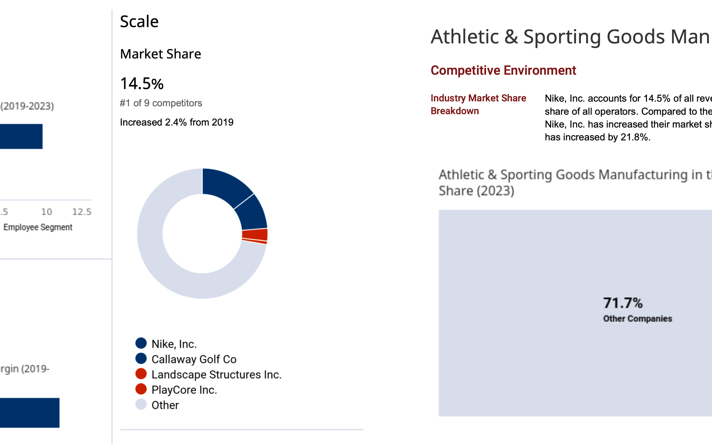[Nike Inc - Athletic Shoe Stores - IBISWorld](https://my-ibisworld-com.proxy.library.nyu.edu/us/en/company-benchmarking/9086/company-overview)

**3. Obstacles to Online Growth**

Nike generates $3.1 billion in income from the very competitive online shoe sales business, where it holds a considerable 14.9% market share despite fierce competition, especially from heavyweights like Amazon. Despite being difficult, this market has forced Nike to innovate digitally and improve its online presence.

**4. Excellence in Manufacturing**

Nike is still a major player in the athletic and sporting goods manufacturing sector, with a 14.5% market share and $1.6 billion in revenue in 2023. This clip demonstrates Nike's dedication to producing items of the highest caliber and inventiveness that appeal to a wide range of consumers.

**5. Future Prospects and Strategic Alignment**

Nike's growth has been largely attributed to its strategic efforts. The company's future course is being shaped by its emphasis on sustainable innovation, digital transformation, and direct-to-consumer sales. Nike's ability to adjust its product ranges and marketing methods to changing consumer preferences and technology breakthroughs is commendable.

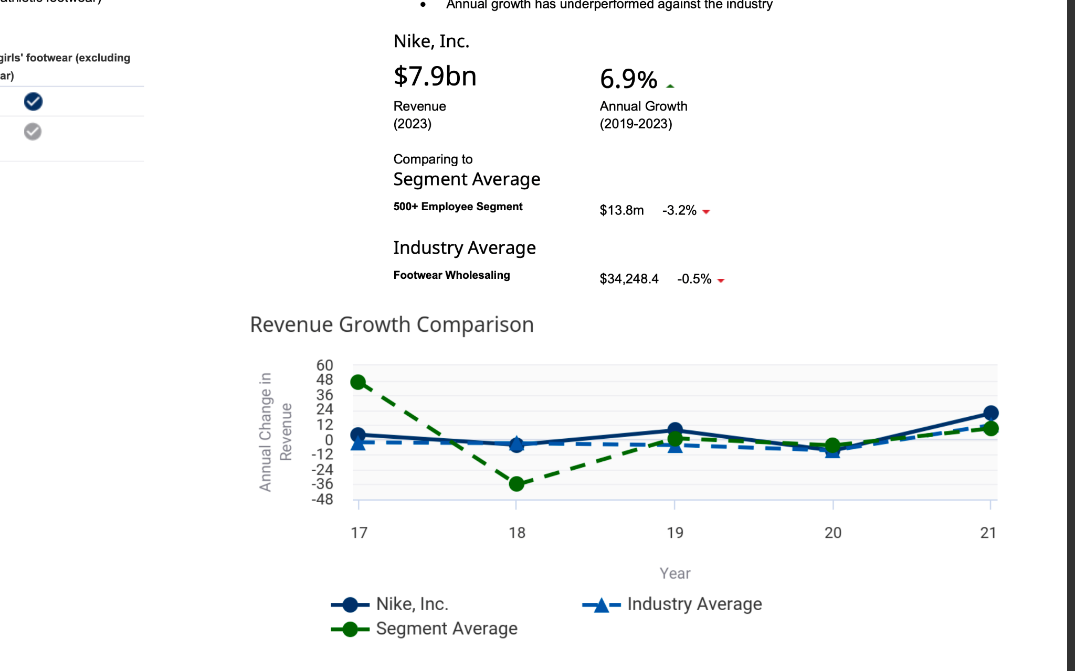

[Footwear Wholesaling: Nike Inc - Footwear Wholesaling - IBISWorld Company Profile](https://my-ibisworld-com.proxy.library.nyu.edu/us/en/company-benchmarking/9086/company-overview)  
  
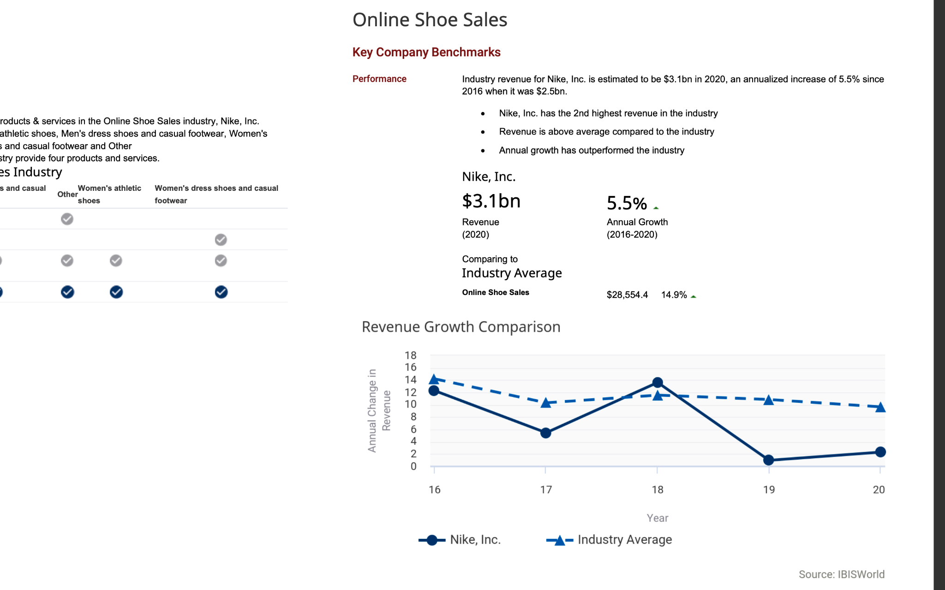  
[Online Shoe Sales: Nike Inc - Online Shoe Sales - IBISWorld Company Profile](https://my-ibisworld-com.proxy.library.nyu.edu/us/en/company-benchmarking/9086/company-overview)

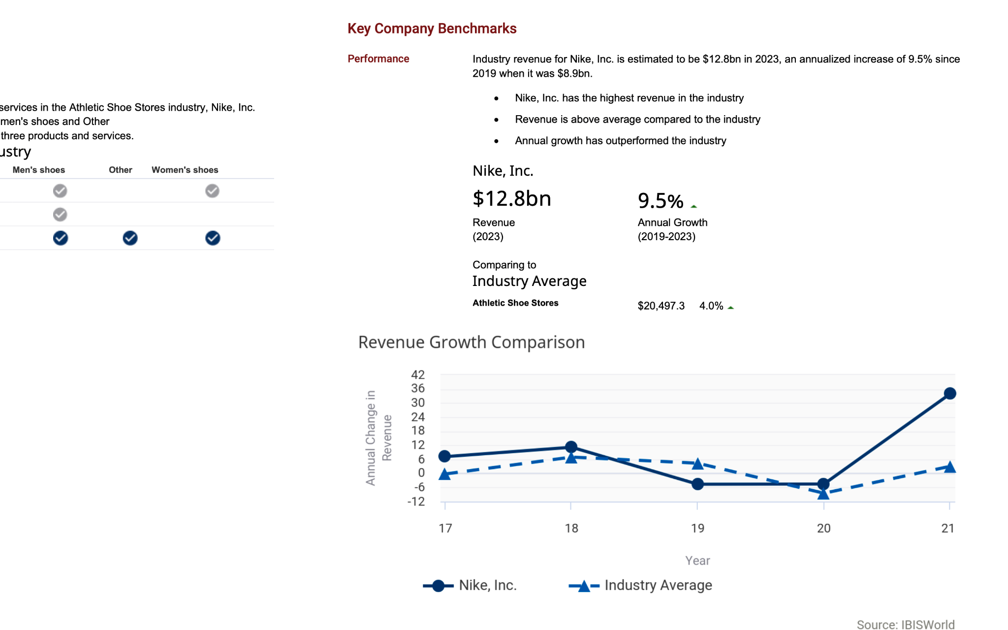  
[Athletic & Sporting Goods Manufacturing: Nike Inc - Athletic Sporting Goods Manufacturing - IBISWorld Company Profile.pdf](https://my-ibisworld-com.proxy.library.nyu.edu/us/en/company-benchmarking/9086/company-overview)

To further penetrate new markets and increase its digital footprint, Nike will need to make use of its tremendous brand equity. Nike is well-positioned to sustain its leadership in the global market by making continuous investments in sustainability and technology and innovating in ways that appeal to customers everywhere.

**Source:** [IBIS World](https://my-ibisworld-com.proxy.library.nyu.edu/us/en/company-benchmarking/9086/company-overview)

## B. Supply Chain Techniques

**Supply Chain Analysis of Nike: A Strategic Synopsis**

Nike's cost leadership strategy in the fiercely competitive sportswear and footwear business is a shining example of operational restraint and careful cost control. The main method used to do this is a carefully planned rationalization of supply chain procedures. Nike effectively controls production costs while upholding strict standards for ethical behavior and quality by outsourcing to geographically varied countries that offer cost efficiencies. Utilizing state-of-the-art logistics technology and centralized procurement systems is essential to this approach since they improve distribution network efficiency, drastically lower transportation costs, and increase overall cost-effectiveness. This tactic is essential for protecting the business from major worldwide interruptions like the COVID-19 epidemic and other geopolitical unrest that might negatively impact production costs and obstruct international trade.

**1. Efficiency and Cost Reduction**

Nike has demonstrated its strategic insight in retaining cost leadership while sustaining ethical standards and high-quality production through its approach to global supply chain optimization. This tactic is especially important for reducing the risks brought on by major worldwide disruptions like the COVID-19 epidemic and geopolitical unrest, which seriously jeopardize steady manufacturing costs and smooth international trade.

Nike's strategic decision to outsource production to locations that meet the company's strict requirements for ethical behavior and quality as well as cost savings is the cornerstone of this strategy. Nike guarantees that it maintains its core principles while reaping the benefits of reduced operating expenses by doing this. In a market where consumer trust and brand integrity are becoming more and more important, striking this careful balance is essential.

Additionally, Nike uses centralized procurement systems and advanced logistics technologies to improve the effectiveness of its distribution networks. These technologies are essential for cutting transportation costs and enhancing the responsiveness of the supply chain as a whole. Nike can ensure that its products are competitively priced even in the face of changing market conditions by optimizing its distribution systems to deliver goods to the market more quickly.

Nike's supply chain's capacity to quickly change to outside challenges is supported by its adaptable tactics that enable prompt operational adjustments. In the face of uncertainty, this flexibility is essential to preserving profitability and preserving the company's position in the market. Nike's attempts to streamline their operations demonstrate a profound comprehension of the dynamics of global supply chains, which enables the corporation to provide reasonably priced, superior products to customers across the globe.

**2. Operational Coordination**

Nike's ability to effectively handle complicated supply chain logistics is largely attributed to its strategic application of cutting-edge technical tools to synchronize its operations worldwide. Nike maintains a high level of operational harmony throughout its vast network by integrating its Advanced Planning and Scheduling (APS) and Enterprise Resource Planning (ERP) systems. This guarantees that every department, from production to distribution, runs effectively.

Nike is able to leverage real-time data analytics thanks to this technology integration, which is essential for matching manufacturing to changing consumer needs. Nike avoids overproduction and saves inventory costs by having the flexibility to modify production schedules in response to real-time customer data and inventory levels. By doing this, Nike is able to better meet the demands of its customers and save waste while also increasing customer happiness and loyalty.

Nike's cooperation with manufacturers and suppliers located on various continents is another example of operational synchronization in action. Nike strengthens the resilience of its supply chain by making sure these partners adhere to Nike's quality standards and achieve production deadlines. This is especially crucial for reducing the risks of supply chain disruptions brought on by events like labor conflicts or natural catastrophes, which can seriously affect business operations.

In addition to improving operational effectiveness, Nike's strategic synchronization of its operations aims to build a strong foundation that promotes long-term success and sustainable business practices. Nike has demonstrated its dedication to using technology to sustain its leadership in the sportswear sector through the integration of its ERP and APS systems.

**3. Customer Engagement and Product Personalization**

Nike places a strong emphasis on personalization at the center of their marketing strategy since it greatly increases customer engagement and boosts revenue. Customers can personalize their purchases with the firm through platforms like Nike By You, offering a distinctive shopping experience that strengthens the emotional bond between the brand and its patrons. In addition to differentiating Nike from its rivals, this degree of personalization helps premium pricing methods that increase profit margins.

Nike's supply chain is extremely adaptable and quick to respond, which is essential to the company's customization approach. Nike's logistical operations are strong and flexible enough to handle a wide variety of customized orders with efficiency. Nike guarantees that the manufacturing and delivery of customized goods are carried out with the same caliber and effectiveness as their regular product lines by preserving this flexibility.

Customization also goes beyond simply raising customer satisfaction levels; it turns traditional shopping into a fun and participatory experience that encourages brand promotion and loyalty. Nike builds a devoted customer base that appreciates being able to customize items to their tastes in addition to satisfying the growing demand for personalized products by allowing customers to participate in the design process.

**4. Leadership Through Innovation**

Nike's corporate culture places a strong emphasis on innovation, which is essential to the company's ability to stay competitive in the world's sportswear market. Nike's unwavering commitment to research and development drives ongoing advancements in product functionality and design, keeping the brand at the forefront of both consumer and industry trends.

Nike is dedicated to innovation throughout the whole supply chain, not only in terms of product design. Nike's supply chain agility facilitates quicker product launches and rapid prototyping, allowing the corporation to react swiftly to changing trends. To take advantage of market possibilities and maintain Nike's market leadership, this quick reaction time is essential.

Furthermore, Nike's inventive methods strongly correspond with its eco-friendly objectives. Nike is lessening its operational impact on the environment while simultaneously meeting consumer demand for sustainable products through the development of eco-friendly materials and methods. Nike's brand image and attractiveness are enhanced by their dedication to sustainability, especially among consumers who care about the environment.

In summary, Nike's strategy emphasis on innovation propels the company's leadership in sportswear and solidifies its standing as an ethical global business leader. Nike creates new industry standards by consistently incorporating sustainable practices and state-of-the-art technologies into their supply chain. This approach fosters both environmental stewardship and financial success.

**Sources:** [CNBC](https://www.cnbc.com/2021/09/24/nike-can-turn-its-snarled-supply-chain-to-its-advantage.html), [Issu](https://issuu.com/navyasriparasa/docs/navyasri_parasa_-_sustainability_in_business_and_d/s/11065687), [samuellearning](http://samuellearning.org/scm/Session%207%20Handout.pdf), [CFO Brew](https://www.cfobrew.com/stories/2022-07-26-nike-digital-supply-chain), [Standford](https://www.gsb.stanford.edu/faculty-research/publications/nikes-strategy-improve-conditions-its-global-supply-chain-case-study)  
  
**Operational Mastery: Nike's Integrated Approach to Global Supply Chain Excellence**

### **1. Global Production and Sourcing Efficiency**

Nike has successfully maintained its market dominance through its global sourcing and production strategy, as seen by its considerable revenue of $7.9 billion from footwear wholesaling and $12.8 billion from athletic shoe stores as of 2024. By utilizing regional variety, this strategy maximizes manufacturing costs and improves market response. In addition to reducing manufacturing costs, Nike's decision to outsource production to less expensive locations enables a scalable response to shifting global market dynamics.

The company's effective penetration and competitive advantage in these areas are highlighted by its overwhelming market share of 62.5% in athletic shoe stores and 23.6% in footwear wholesale. Nike maintains its market leadership through strategic collaborations with local suppliers, allowing it to quickly adapt to consumer preferences and market developments while upholding high standards of ethical production and quality.

Additionally, Nike's strong logistical infrastructure—which includes centralized procurement and cutting-edge distribution systems—complements its strategic outsourcing. These systems improve the business's operational effectiveness by guaranteeing that goods are supplied to different markets in a timely and economical manner. To remain competitive in the global market and provide excellent service, Nike must strategically locate its distribution centers near important markets to minimize travel times and logistical expenses.  
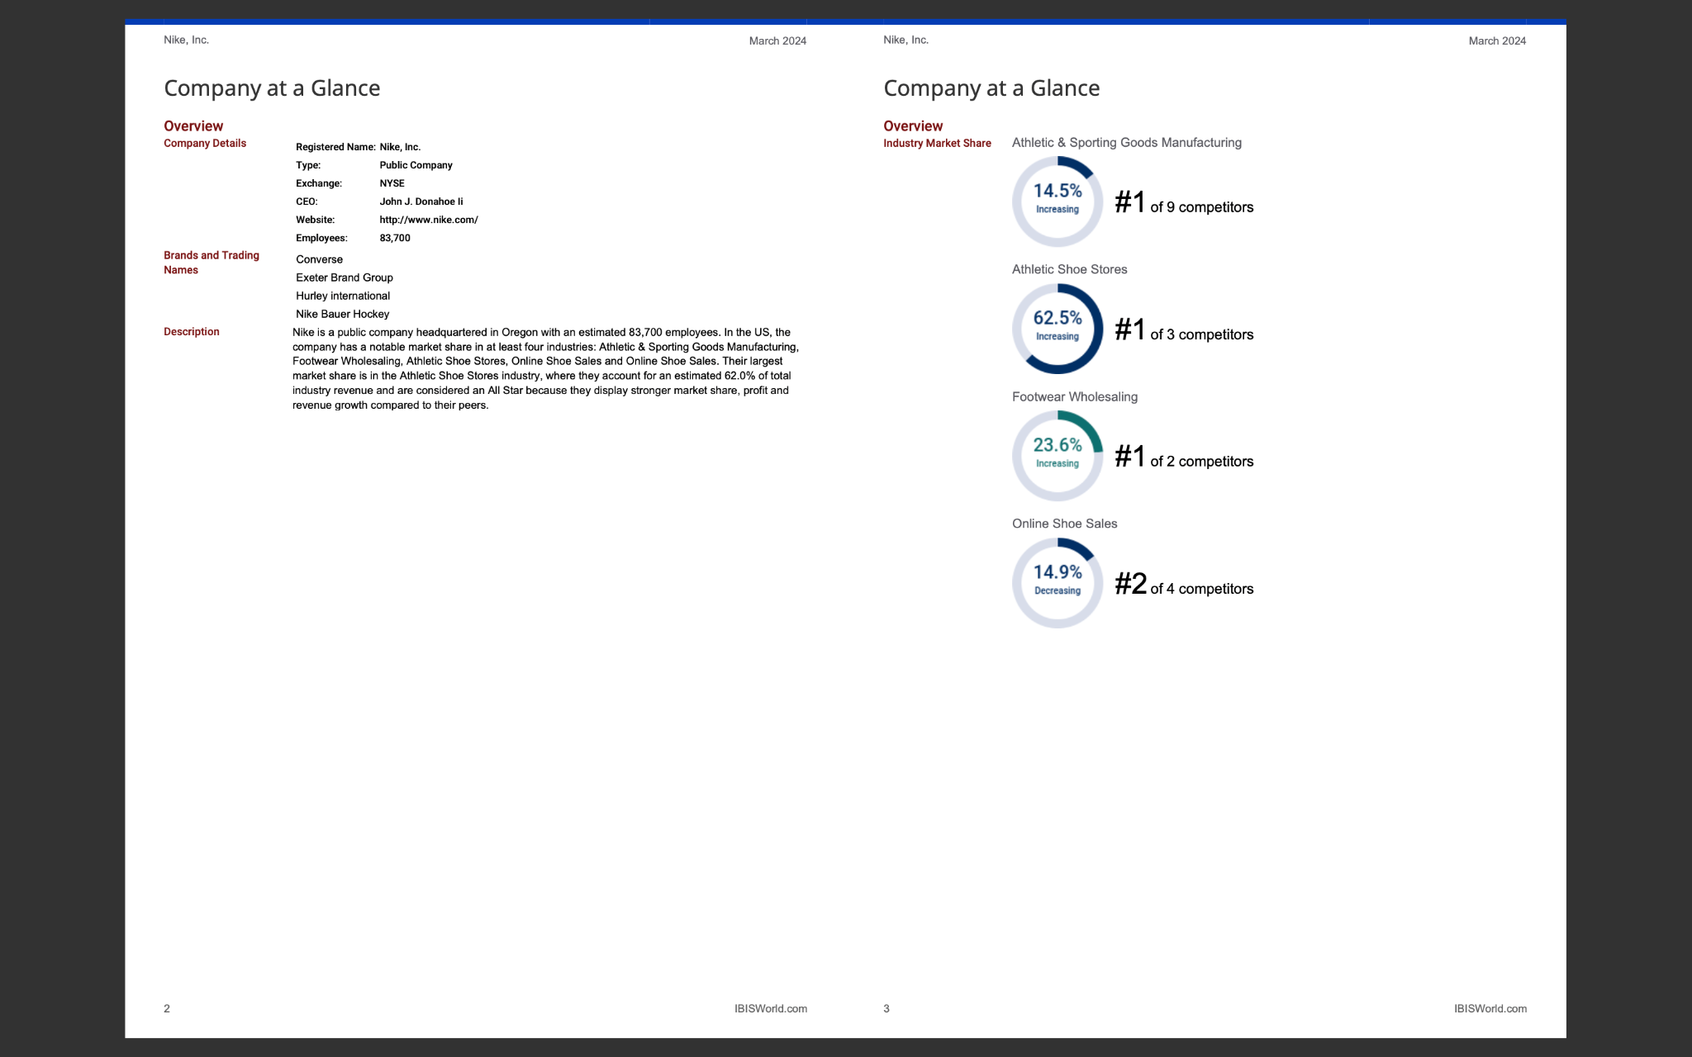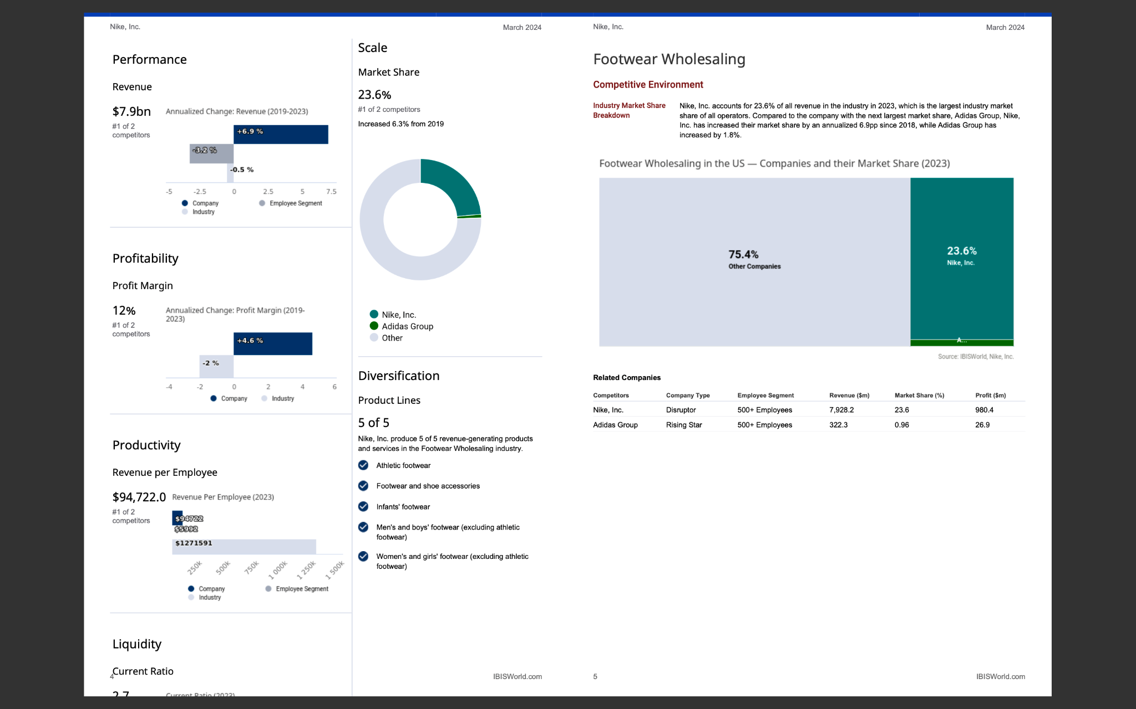

### **2. Technological Integration for Supply Chain Synchronization**

Nike's high technological integration, particularly its enterprise resource planning (ERP) and advanced planning and scheduling (APS) systems, significantly supports supply chain synchronization. These technologies serve as the foundation for global supply chain management and real-time data analytics, enabling Nike to precisely estimate demand, maximize inventory levels, and cut down on waste.

Thanks to its technological prowess, Nike can keep its global operations in line with changing market demands and operational efficiencies. Nike can make the most efficient use of supply and demand by utilizing real-time data to modify production plans and inventory distribution. This skill is essential for reducing overstocks and stock-outs, which have a big influence on profitability.

Information may also move smoothly between suppliers, manufacturers, and retailers at every stage of the supply chain thanks to the ERP and APS systems. Improving communication and teamwork is crucial for adapting quickly to shifting consumer preferences and market dynamics, and this integration does just that. It furthers Nike's commitment to sustainability by facilitating resource efficiency and lowering the company's operational impact on the environment.

### 

### **3. Customization and Consumer Engagement**

Nike's strategic emphasis on consumer involvement is exemplified by its emphasis on customization through the Nike By You platform. Customers may now customize their purchases thanks to this effort, which improves their purchasing experience and fortifies their emotional bond with the company. In addition to setting Nike apart from its rivals, this customized approach fuels premium pricing tactics that support the business's robust profitability, as shown by its steady 12% profit margin across all industries.

Offering bespoke products necessitates a supply chain that is extremely agile and adaptable. Nike accomplishes this by combining cutting-edge manufacturing processes with an efficient logistical system that can swiftly adjust to requests for customized output. Because it enables Nike to provide a large range of customization options without experiencing appreciable delays in product delivery, this adaptability is essential to sustaining high customer happiness and loyalty.

Customization also helps Nike's market positioning by meeting the increasing demand from customers for distinctive and individualized goods. In addition to raising the perceived value of Nike's products, this approach promotes increased consumer spending and repeat business, both of which are essential for maintaining long-term revenue growth and market share expansion.

### **4. Innovation and Market Leadership**

Nike's strategy is centered on innovation, which has an impact on its supply chain procedures as well as its product offerings. Nike is able to maintain its leadership position in the sportswear sector because of its significant investment in research and development, which fosters continuous product innovation. These developments, which meet consumer demands and environmental sustainability goals, span from high-performance materials and designs to eco-friendly products.

Nike has built its supply chain to facilitate quick innovation. The company's rapid methods enable swift modifications from concept to production, allowing it to launch new goods ahead of its rivals. Maintaining a competitive edge and taking advantage of new market opportunities require this fast cycle of innovation.

Nike's creative approach also reaches its supply chain management procedures. The organization consistently investigates novel technologies and procedures that have the potential to improve productivity and save expenses, like demand planning with artificial intelligence and warehousing automation. These developments strengthen Nike's supply chain's overall resilience and agility in addition to increasing operational efficiency.

Nike keeps a laser-like focus on innovation, which not only helps them hold the top spot in the market but also establishes benchmarks for sustainability and performance. Nike's ability to successfully negotiate the intricacies of a worldwide market and its long-term success is directly linked to its strategic emphasis on adaptation and constant improvement.  
  
**Sources:** [CNBC](https://www.cnbc.com/2021/09/24/nike-can-turn-its-snarled-supply-chain-to-its-advantage.html), [samuellearning](http://samuellearning.org/scm/Session%207%20Handout.pdf), [CFO Brew](https://www.cfobrew.com/stories/2022-07-26-nike-digital-supply-chain), [Standford](https://www.gsb.stanford.edu/faculty-research/publications/nikes-strategy-improve-conditions-its-global-supply-chain-case-study)**,** [IBIS World](https://my-ibisworld-com.proxy.library.nyu.edu/us/en/company-benchmarking/9086/company-overview)

**Navigating Challenges and Seizing Opportunities**

Nike constantly has to deal with supply chain interruptions brought on by international unpredictabilities like trade wars and pandemics. Nike sees these difficulties as a chance to improve its sustainability and supply chain resilience even more. Nike is positioned to satisfy changing customer needs and comply with environmental regulations because of its continuous investments in sustainability and digital transformation.  
  
**1. Challenge: Global Supply Chain Disruptions**

**Problem**: Because of its wide-ranging international activities, Nike is subject to a variety of hazards, including natural disasters, unstable political environments, and changes in national regulations. The whole supply chain may be disrupted by these interruptions, which may result in unexpected shortages of essential commodities, the shutdown of production facilities, or protracted delays in transit.

**Impact**: Nike's capacity to meet demand in important markets was impacted by severe supply shortages that resulted from the closure of plants in Vietnam owing to COVID-19. If customers go to competitors' offerings, these disruptions harm long-term customer relationships in addition to short-term revenue.

**Recommended Solution**: Adopt a dual-sourcing approach for all essential parts and supplies. Nike has the potential to cultivate partnerships with ancillary suppliers across many regions to guarantee uninterrupted production in the event of regional interruptions. Nike could also spend money on an advanced supply chain risk management system that employs machine learning to anticipate possible disruptions and automatically modify supply chain operations ahead of time.

**2. Challenge: Cost Fluctuations and Rationalization**

**Problem**: Due to unforeseeable global economic reasons, trade policies, and market conditions, the cost of raw materials, such as cotton or synthetic fabrics, constantly changes. As economies grow and regulations mount, labor costs are also growing in manufacturing nations.

**Impact**: Increasing expenses may put pressure on profits, particularly if Nike is unable to pass these expenses through to customers without losing market share to less costly rivals. Maintaining profitability while simultaneously making investments in innovation and sustainability depends on this delicate balancing act.

**Recommended Solution**: Nike can reduce the impact of price volatility by locking in the pricing of necessary raw materials through the use of hedging strategies. Stabilizing costs might also be achieved by establishing long-term contracts with important suppliers that have provisions for price modifications based on certain market indices.In order to cut expenses and transit times while retaining manufacturing in lower-cost areas, Nike may also consider nearshoring some production activities to areas near important markets.

**3. Challenge: Customization Complexity**

**Problem**: Handling a large variety of bespoke items makes inventory control, shipping, and production procedures more difficult. This calls for a precise and adaptable supply chain.

**Impact**: Every customized order introduces unpredictability to the production process, which may result in waste accumulation and inefficiencies. This can go against Nike's environmental objectives and cause a backlog in operations.

**Recommended Solution**: Introduce leading-edge production technology like robotic assembly lines and automated cutting machines that are made expressly to handle personalized requests. To shorten lead times for tailored items, these technologies can be incorporated into specific key sites, possibly close to large markets. The customization process can be streamlined from order to delivery by putting in place a more reliable IT infrastructure that links client interaction platforms with manufacturing floor equipment directly.

**4. Challenge: Fast-paced Innovation Demands**

**Problem:** Due to intense competition, the sportswear industry demands constant product innovation to satisfy customers' needs and set industry trends. The swift conversion of these breakthroughs into large manufacturing poses a challenge to the current supply chain frameworks

**Impact:** New products may be delayed or released without sufficient market testing in the absence of a flexible supply chain, which could negatively impact brand perception and customer reaction.

**Recommended Solution:** Create specialized innovation hubs with an emphasis on developing and testing new products in close coordination with regional markets in strategic locations across the globe. These centers can expedite the design and approval stages by utilizing rapid prototyping methods like digital fabric simulation and 3D printing. Product launches can be made even more rapid and effective by collaborating with third-party logistics companies that provide customizable warehousing and distribution services.

**5. Challenge: Ensuring Sustainability and Compliance**

**Problem**: It is difficult to implement a consistent sustainability standard across all activities  
globally, particularly in areas with laxer regulations or disparate cultural perspectives on environmental issues.  
  
**Impact**: Variations in environmental compliance can put a company's reputation in jeopardy and possibly result in customer boycotts from green-conscious shoppers. Regulations that impose fines and limits may also result from not meeting sustainability standards.  
  
**Recommended Solution**: Create a worldwide sustainability dashboard that monitors supplier adherence to Nike's environmental criteria in real time, taking into account carbon emissions, water usage, and waste management. To guarantee universal compliance, Nike should also invest more in training programs for suppliers on sustainable practices, especially in areas with lax regulations. Nike can encourage the entire industry to adopt greener practices by forming collaborations to produce recyclable materials and recycling systems.

**6. Challenge: Dynamic Market Demands and Inventory Management**

**Problem**: New trends, advertising campaigns, and rival inventions can cause consumer preferences to change quickly. The shifting demand landscape poses a unique challenge to inventory management.

**Impact:** Overstocking or stockouts can be caused by a mismatch between production and real market demand, which is bad for Nike's bottom line and standing in the marketplace.

**Recommended Solution**: Implement an advanced artificial intelligence (AI)--enhanced enterprise resource planning (ERP) system for dynamic inventory control. In order to more precisely estimate demand, this system would examine sales data, social media trends, and other market indications. Nike might also put in place an omnichannel inventory system, which would make it easy to move merchandise between physical locations and online platforms to react fast to shifting customer trends.

**Sources:** [CNBC](https://www.cnbc.com/2021/09/24/nike-can-turn-its-snarled-supply-chain-to-its-advantage.html), [Issu](https://issuu.com/navyasriparasa/docs/navyasri_parasa_-_sustainability_in_business_and_d/s/11065687), [samuellearning](http://samuellearning.org/scm/Session%207%20Handout.pdf), [CFO Brew](https://www.cfobrew.com/stories/2022-07-26-nike-digital-supply-chain), [Standford](https://www.gsb.stanford.edu/faculty-research/publications/nikes-strategy-improve-conditions-its-global-supply-chain-case-study)

## C. Supply Chain Performance

Nike employs a comprehensive, integrated strategy in its supply chain management, focusing on four main areas: **Rationalization, Customization, Synchronization, and Innovation**. These strategies aim to enhance operational efficiency, meet customer needs, respond swiftly to market changes, and incorporate cutting-edge technologies and sustainable practices.

**Rationalization for Efficiency**

The primary objective of Nike’s rationalization strategy is to optimize and reduce costs across the supply chain to boost overall operational efficiency. This strategy is crucial in maintaining competitive pricing while ensuring product quality and profitability.

**Key Performance Indicators:**

**Cost of Goods Sold (COGS):** Nike strives to minimize these costs through lean manufacturing practices which enhance labor productivity and material consolidation. This aspect of rationalization became particularly vital during the disruptions caused by the COVID-19 pandemic, where supply chain agility and cost efficiency were key to navigating the economic impacts.([Yahoo Finance](https://finance.yahoo.com/quote/NKE/history/?guccounter=1&guce_referrer=aHR0cHM6Ly93d3cuZ29vZ2xlLmNvbS8&guce_referrer_sig=AQAAAKjnPM_jV6gp5ztsQLkeAIJBSvH-gF2nCiac1Ve77t6Z82TQJ-Ij66J0DdOxBrS0xTh8T7hiTUyL1ZlQPTpWqUYpy2AgyLiQ63wHCZRy4ZWD43uFYgqjdu7qybbWpV0xIXB7Tk9Fljd3EjY5QZX03W_6F-mbNzVNPoLKaVqQtVxF) )

**Inventory Turnover:** Maintaining high inventory turnover is essential for reducing holding costs and ensuring product freshness. Despite the challenges posed by the pandemic, such as fluctuations in demand and logistic disruptions, Nike has focused on bolstering its Direct-to-Consumer channels and optimizing regional distribution centers to maintain effective inventory levels. High inventory turnover not only helps in managing storage costs but also in aligning production with current market trends and consumer demands.( [Sole Retriever](https://www.soleretriever.com/sneaker-release-dates?search=nike))

**Customization to Meet Customer Needs**

Customization at Nike aims to enhance customer experience and foster brand loyalty by allowing consumers to personalize products. This strategy taps into the growing consumer preference for products that reflect individual style and functionality choices.

**Key Performance Indicator: Gross Margin**

The use of "Nike By You," Nike’s product customization platform, exemplifies this strategy. Gross Margin is a critical KPI for assessing the financial impact of customization, as personalized products often command a higher price point, contributing positively to profitability. Customization not only meets customer desires but also creates a value-added perception, which can significantly drive up gross margins. It’s a dual benefit where customer satisfaction is bolstered, and economic gains are realized through premium pricing.

**Synchronization for Market Responsiveness**

The synchronization strategy ensures that all supply chain assets are maximally utilized to achieve efficient production and distribution. This strategy is crucial for responding swiftly to market changes and maintaining continuous supply chain operations.

**Key Performance Indicator: Supplier On-time Delivery Rate**

This KPI is vital as it measures the efficiency and reliability of the supply chain in procuring materials from suppliers on time, which is essential for maintaining uninterrupted production schedules and meeting market demands promptly. Nike’s robust supplier network is strategically developed to mitigate potential delays and enhance the overall responsiveness of the supply chain.([Yahoo Finance](https://finance.yahoo.com/quote/NKE/history/?guccounter=1&guce_referrer=aHR0cHM6Ly93d3cuZ29vZ2xlLmNvbS8&guce_referrer_sig=AQAAAKjnPM_jV6gp5ztsQLkeAIJBSvH-gF2nCiac1Ve77t6Z82TQJ-Ij66J0DdOxBrS0xTh8T7hiTUyL1ZlQPTpWqUYpy2AgyLiQ63wHCZRy4ZWD43uFYgqjdu7qybbWpV0xIXB7Tk9Fljd3EjY5QZX03W_6F-mbNzVNPoLKaVqQtVxF) )

**Innovation as a Competitive Edge**

Innovation drives Nike’s market leadership and operational efficiency, focusing on integrating cutting-edge technologies and sustainable practices into product development and supply chain processes.

**Key Performance Indicator: Sales Growth**

Sales growth is a direct reflection of the market’s reception to Nike’s innovations, particularly those that emphasize sustainability and advanced technology. Innovations such as eco-friendly materials and digitally integrated products not only cater to consumer interests but also open new revenue streams. Monitoring sales growth helps Nike evaluate the effectiveness of its innovative strategies in capturing market interest and driving revenue.

**Challenges and Recommendations**

Nike's supply chain strategies are crucial for maintaining its competitive edge, addressing operational challenges, and achieving corporate goals. Here we delve into specific challenges identified within Nike's supply chain and propose strategic recommendations to address these issues.

**1. Supply Chain Disruptions and Inventory Management**

**Strategy: Rationalization**

**KPIs Impacted:** Inventory Turnover Rate, Inventory Accuracy

**Evidence:** During fiscal 2020, Nike experienced a 31% increase in inventory, largely due to supply chain disruptions amid the COVID-19 pandemic.

**Problem Identification:** The primary challenge is optimizing inventory levels to handle fluctuating consumer demand effectively, thereby minimizing both stockouts and excess stock. This affects critical KPIs such as inventory turnover rate and accuracy.

**Recommendations:**

* Implement Advanced Predictive Analytics: Employ sophisticated forecasting tools to better predict consumer demand patterns and adjust inventory levels accordingly.
* Enhance Real-Time Inventory Management: Develop systems that can dynamically adjust inventory based on real-time sales data and supply chain conditions to prevent overstocking and understocking.
* Strengthen Supply Chain Resilience: Invest in diversifying suppliers and logistics options to reduce the impact of disruptions on inventory levels.

**2. Digital Transformation Pressure on Supply Chain**

**Strategy : Customization**

**KPIs Impacted :** Order Fulfillment Speed, Return Management Efficiency, Digital Sales Growth, Gross Margin

**Evidence:** Fiscal 2021 saw a 73% increase in Nike Direct fourth quarter sales, indicating a significant shift towards online shopping.

**Problem Identification:** The growth in digital sales requires the supply chain to adapt efficiently for last-mile delivery, returns processing, and overall customer experience, impacting KPIs like order fulfillment speed and digital sales growth.

**Recommendations:**

* Optimize Last-Mile Delivery: Utilize advanced logistics solutions, including localized distribution centers or partnering with logistics tech companies, to enhance delivery efficiency.
* Invest in Technology: Implement systems like blockchain and IoT to improve transparency and tracking, ensuring smoother operations from order to delivery.
* Enhance Customer Return Processes: Develop streamlined, customer-friendly return processes that integrate seamlessly with the supply chain operations.

**3. Sustainability Targets and Operational Efficiency**

**Strategy : Innovation**

**KPIs Impacted :** Carbon Footprint, Cost Efficiency

**Evidence:** Nike's 2021 Impact Report highlights ambitious goals for reducing its environmental footprint.

**Problem Identification:** Integrating sustainability into operations demands a reevaluation of sourcing and manufacturing processes, which impacts KPIs related to carbon footprint and cost efficiency.

**Recommendations:**

* Sustainable Sourcing Practices: Shift towards more sustainable raw materials that are less taxing on the environment without compromising the supply chain efficiency.
* Invest in Green Technology: Adopt energy-efficient technologies in manufacturing processes to reduce both carbon footprint and operating costs.

**4. Global Supply Chain Diversification**

**Strategy : Synchronization**

**KPIs Impacted :** Supply Chain Risk Management, Logistics Efficiency, Market Share Growth

**Evidence:** Nike's revenue growth across different regions underscores the global nature of its supply chain.

**Problem Identification:** Managing a diversified global supply chain adds complexities in balancing regional demands with cost optimization, impacting KPIs related to market share growth and logistics efficiency.

**Recommendations:**

* Enhance Regional Adaptation: Customize supply chain strategies to regional market conditions and consumer preferences to improve responsiveness and efficiency.
* Strengthen Global Partnerships: Build robust relationships with local suppliers and logistics providers to enhance flexibility and reduce dependency on any single market or source.

**5. Cost Management and Gross Margin Optimization**

**Strategy: Rationalization**

**KPIs Impacted :** Gross Margin, Operation Cost Savings, COGS

**Evidence:** Nike aims to achieve $2 billion in cost savings by fiscal 2025, with a focus on operational efficiency.

**Problem Identification:** Balancing aggressive cost-cutting measures with necessary investments in growth and sustainability poses a challenge, affecting KPIs like gross margin and innovation investment.

**Recommendations:**

* Lean Manufacturing Practices: Implement lean manufacturing techniques to reduce waste and improve efficiency without compromising product quality.
* Focus on High-Value Innovations: Prioritize investments in innovations that promise high returns on investment, such as eco-friendly products that can command premium prices.
* Each of these challenges, when addressed effectively through these strategic recommendations, can significantly enhance Nike's supply chain operations, leading to improved efficiency, customer satisfaction, and profitability.

**Sources:** [NIKE, Inc. (2020)](https://about.nike.com/en/newsroom/reports/nike-inc-reports-fiscal-2020-fourth-quarter-and-full-year-results) , [NIKE,Inc(2021)](https://about.nike.com/en/newsroom/reports/nike-inc-reports-fiscal-2021-fourth-quarter-and-full-year-results) , [NIKE, Impact(2021)](https://about.nike.com/en/newsroom/reports/fy21-nike-inc-impact-report-2)

## D. Supply Chain Agility

Nike's supply chain agility is designed to meet the challenges of a fast-paced global market by leveraging advanced technologies and proactive strategies. The current state of Nike's supply chain agility and flexibility showcases a concerted effort to harness digital technologies and innovative practices to enhance operational efficiency and consumer satisfaction.

**1. ERP System Overhaul for Greater Agility**

Nike's ongoing overhaul of its ERP systems, initiated in 2020, is a strategic move to enhance supply chain responsiveness and agility. This initiative aims to unify and streamline financial and inventory management across global markets, particularly in dynamic regions like China. The integration of advanced analytics and automation tools is crucial, allowing Nike to adapt swiftly to changing consumer demands and market conditions.

**2. Direct-to-Consumer (D2C) Strategy for Supply Chain Agility**

Nike's acceleration of its D2C strategy enhances its supply chain agility by reducing reliance on traditional retail channels. This direct approach allows Nike to more quickly adapt to consumer trends and preferences, streamlining logistics and inventory management. Collaborations, like the partnership with Dick's Sporting Goods, utilize integrated loyalty programs to boost consumer engagement, thereby tightening the feedback loop and enhancing the agility of Nike's supply chain.

**3. Enhanced Supply Chain Agility through Digital Transformation and Robotics**

Nike’s digital transformation strategy, particularly within its logistics operations, exemplifies its commitment to increasing supply chain agility. This strategy integrates sophisticated ERP systems with the deployment of over 1,000 robots across distribution centers, which significantly streamlines operations. These technological advancements enable Nike to enhance order processing speed, reduce manual labor, and improve overall logistical efficiency. The use of robotic process automation, along with real-time data analytics, allows Nike to quickly adapt to changing market demands and consumer preferences, thus reducing the turnaround time from production to delivery. This holistic approach to digital transformation ensures that Nike’s supply chain is flexible, responsive, and well-equipped to handle the dynamics of the global market efficiently.

**4.Agile Response to Supply Chain Disruptions**

Nike has demonstrated its supply chain agility through effective responses to disruptions such as extended transit times and factory closures in critical production areas like Vietnam. By quickly recalibrating supply and demand and ensuring rapid restoration of operational status in factories, Nike minimizes disruptions and maintains a continuous flow of products.

**Alertness in Nike’s Supply Chain: Harnessing Intelligence for Proactive Management**

In the highly competitive and fast-paced global sportswear market, alertness in supply chain management is crucial for sustaining operational effectiveness and market responsiveness. For Nike, this means not just reacting to changes and challenges as they arise, but proactively managing potential disruptions and leveraging opportunities through heightened awareness and real-time intelligence. This capability to remain vigilant and responsive is integral to Nike's strategy to maintain its leadership position and adapt quickly to consumer needs and market dynamics.

**Current Approach to Alertness**

Nike's existing approach to alertness involves sophisticated market monitoring and data analytics systems that track consumer behavior, supply chain operations, and global market trends. By utilizing advanced technologies and continuous data flow, Nike can swiftly adjust its strategies to align with shifting consumer preferences and emerging market conditions. However, the rapid evolution of global markets and technologies calls for even more rigorous and proactive measures.Nike demonstrates its commitment to alertness within its supply chain through accelerated investments in digital technologies. The overhaul of its digital supply chain systems focuses on leveraging analytics and automation to streamline operations. A significant initiative includes the introduction of regional service centers designed to optimize distribution paths, thereby enhancing consumer satisfaction by reducing delivery times.

**Enhanced Intelligence and Real-Time Monitoring**

The global nature of Nike’s operations exposes it to a myriad of fluctuating factors, including economic shifts, consumer trends, and logistical variables. Staying ahead requires an advanced system of intelligence that not only gathers data but also interprets it to predict future scenarios.

**Challenges and Recommendations**

1. **Challenge:** Keeping pace with rapid changes in consumer preferences and market conditions.

**Recommendation:** Implement cutting-edge predictive analytics that integrate artificial intelligence and machine learning to forecast trends and potential disruptions more accurately.

**Action Steps:** Deploy AI models that analyze large datasets from social media, sales data, and global economic indicators to predict consumer behavior changes and market shifts.

1. **Challenge:** Coordinating real-time data across Nike’s extensive global supply chain to maintain operational agility.

**Recommendation:** Enhance the integration of real-time data monitoring systems across all levels of the supply chain to improve response times to supply chain disruptions or market changes.

**Action Steps:** Develop a unified platform that consolidates data across different segments of the supply chain for instantaneous access and response.

1. **Challenge:** Ensuring that critical information reaches all relevant stakeholders timely and effectively.

**Recommendation:** Strengthen communication channels within the organization and with external partners to ensure fast and accurate information flow.

**Action Steps:** Implement advanced communication tools that facilitate real-time sharing of insights and alerts with all stakeholders, enhancing collective responsiveness.

1. **Challenge:** Maintaining continuous oversight of market conditions and internal operations without overwhelming decision-makers with data.

**Recommendation:** Create dynamic feedback loops within the supply chain that not only monitor but also learn and adapt from ongoing operations.

**Action Steps:** Utilize IoT devices and sensors within manufacturing and distribution processes to gather operational data, which is then analyzed and fed back into the system for ongoing optimization.

By fortifying its capabilities in alertness, Nike can better anticipate and respond to changes, ensuring operational efficiency and market adaptability. This proactive approach allows Nike to not just respond to immediate challenges but also strategically align its operations with long-term market trends and consumer behaviors. Enhancing predictive analytics, improving real-time data integration, optimizing communication, and establishing continuous monitoring systems are critical steps toward achieving a truly responsive and aware supply chain. Implementing these strategies will equip Nike to maintain its competitive edge and continue its legacy of innovation and customer satisfaction in the global sportswear market.

**Source:** [Consumer Goods Technology](https://consumergoods.com/nike-accelerates-digital-supply-chain-investments-more-advanced-analytics)

**Accessibility in Nike’s Supply Chain: Enhancing Data Visibility and Integration**

Accessibility in the context of supply chain management refers to the ease with which a company can obtain necessary data and utilize it to make informed decisions. For a global leader like Nike, which operates in a complex and dynamic market environment, enhancing accessibility means not only having the data but also ensuring it is visible, meaningful, and readily available for decision-making processes across the entire organization.

**Current Approach to Accessibility**

Nike has already implemented advanced ERP systems and utilizes various data management tools to ensure the flow of information across its supply chain. However, the challenge remains in fully integrating this data across various functional domains to ensure that all stakeholders have real-time access to pertinent information, thereby enhancing the overall responsiveness of the supply chain.

The integration of robotics in distribution centers underscores Nike's commitment to enhancing supply chain accessibility and efficiency. With over 1,000 robots deployed to automate tasks, Nike has significantly reduced manual labor requirements, leading to faster processing times and improved order accuracy. This technological upgrade has been instrumental in maintaining a high level of efficiency in order fulfillment and logistics operations.

Nike demonstrates its commitment to alertness within its supply chain through accelerated investments in digital technologies. The overhaul of its digital supply chain systems focuses on leveraging analytics and automation to streamline operations. A significant initiative includes the introduction of regional service centers designed to optimize distribution paths, thereby enhancing consumer satisfaction by reducing delivery times.

**Strategic Enhancements in Data Management and Visibility**

The accessibility of accurate and real-time data is crucial for Nike to respond swiftly to market changes, manage inventory efficiently, and optimize production schedules. Enhancing this capability involves not only technological upgrades but also organizational adjustments to promote transparency and data sharing.

**Challenges and Recommendations**

1. **Challenge:** Disparate data systems across different regions and departments can hinder the real-time visibility and utility of information.

**Recommendation:** Implement a fully integrated data management system that consolidates all supply chain information into a single platform, accessible by all relevant stakeholders.

**Action Steps:** Utilize cloud-based platforms to ensure data consistency and accessibility, enabling real-time updates and data sharing across global locations.

1. **Challenge:** Key decision-makers often lack visibility into real-time data, affecting the speed and effectiveness of strategic decisions.

**Recommendation:** Enhance data visualization tools within the supply chain management systems to provide clear and actionable insights.

**Action Steps:** Develop dashboards that display critical metrics such as demand volume, commodity prices, and capacity availability, updated in real-time to reflect current market and operational conditions.

1. **Challenge:** Organizational silos can restrict the flow of information, limiting the ability of teams to make informed decisions.

**Recommendation:** Foster a culture of transparency where data is freely shared across departments to encourage more collaborative and informed decision-making.

**Action Steps:** Implement cross-functional teams and regular briefing sessions where data insights are shared and discussed, ensuring all parts of the organization are aligned and informed.

1. **Challenge:** Embedding a data-driven culture across a global organization is complex and requires consistent effort and reinforcement.

**Recommendation:** Train and incentivize employees to utilize data analytics in their routine decision-making processes.

**Action Steps:** Offer training programs focused on data literacy and the use of analytics tools. Recognize and reward teams that effectively use data to drive improvements in their operations.

By enhancing the accessibility of data within its supply chain, Nike can significantly improve its decision-making processes, leading to more efficient operations and better market responsiveness. A comprehensive data integration strategy, improved visibility for decision support, enhanced transparency across the organization, and a strong data-driven culture are key to achieving this goal. These improvements will ensure that Nike remains agile and competitive in a rapidly evolving global market, with the ability to swiftly adapt to new challenges and opportunities as they arise.

**Source:** [Supply Chain Dive](https://www.supplychaindive.com/news/nike-sole-train-distribution-centers-robots/617604/)

**Decisiveness in Nike’s Supply Chain: Enhanced Scenario Planning and Analytical Decision-Making**

In the context of supply chain management, decisiveness is pivotal for maintaining operational fluency and competitive advantage. It involves pre-configuring scenarios, leveraging analytics, identifying strategic options, and evaluating these options against set criteria. For Nike, a leader in the global sportswear market, enhancing decisiveness within its supply chain is crucial, especially in an industry characterized by fast-changing consumer preferences and frequent supply chain disruptions.

**Current Approach to Decisiveness**

Nike has previously demonstrated decisiveness through strategic collaborations and rapid adaptation strategies, such as its partnerships with global retailers to enhance market penetration and consumer reach. However, the company's decisiveness can be significantly augmented through systematic scenario planning and advanced analytics, ensuring more robust and informed decision-making processes.

**Enhanced Scenario Planning**

Nike operates in a volatile market where consumer trends, global trade policies, and regional market dynamics can shift abruptly. The implementation of an advanced scenario planning framework could allow Nike to navigate these complexities more effectively.

**Challenges and Recommendations**

1. **Challenge:** Nike needs to anticipate multiple supply chain scenarios that could impact its operations, ranging from sudden shifts in consumer behavior to disruptions in manufacturing or logistics.

**Recommendation:** Develop a comprehensive scenario planning model that includes a wide range of potential market conditions, consumer trends, and supply chain disruptions. This model should utilize predictive analytics to forecast and prepare for future scenarios.

**Action Steps:** Integrate AI-driven tools to simulate and analyze outcomes based on historical data and projected market trends.

1. **Challenge:** Making informed decisions quickly is essential for maintaining supply chain agility. Nike’s existing data analytics capabilities can be expanded to provide deeper insights into supply chain operations and market demands.

**Recommendation:** Strengthen analytical platforms to process real-time data across Nike’s global supply chain. This should include the deployment of advanced data visualization tools to aid in quick decision-making.

**Action Steps:** Partner with technology providers to enhance Nike's data analytics infrastructure, ensuring it can handle large volumes of data and deliver actionable insights promptly.

1. **Challenge:** Each decision Nike makes has far-reaching implications on its brand reputation, financial performance, and operational efficiency.

**Recommendation:** Establish clear criteria for evaluating different strategic options. These criteria should align with Nike’s broader corporate goals, such as sustainability, customer satisfaction, and profitability.

**Action Steps:** Create a decision matrix that includes weighted criteria based on strategic importance. This matrix will guide decision-makers in evaluating and prioritizing options under different scenarios.

1. **Challenge:** The speed of decision-making can be as critical as the decisions themselves, especially in responding to market and operational challenges.

**Recommendation:** Implement decision-support systems that can provide recommendations based on predefined algorithms and machine learning models.

**Action Steps:** Develop or integrate bespoke decision-support software that connects with Nike’s ERP and SCM systems, providing automated recommendations in real-time.

By enhancing decisiveness in its supply chain, Nike can ensure that it not only responds effectively to immediate challenges but also strategically aligns its operations with long-term market trends and objectives. Implementing sophisticated scenario planning, utilizing advanced analytics, defining clear decision-making criteria, and adopting decision-support technologies will equip Nike to maintain its leadership position and continue its legacy of innovation and market responsiveness.

**Sources:** [Digital Data Design Institute at Harvard](https://d3.harvard.edu/platform-rctom/submission/striding-forward-nikes-quest-to-reinvent-its-supply-chain/) , [Consumer Goods Technology](https://consumergoods.com/nike-accelerates-digital-supply-chain-investments-more-advanced-analytics)

**Swiftness in Nike’s Supply Chain: Enhancing Analytic Processing and Rapid Implementation**

In the dynamic and competitive landscape of global sportswear, the swiftness of a company's supply chain operations can significantly influence its ability to remain competitive and responsive to market changes. For Nike, swiftness is not just about speed; it's about the ability to process analytics quickly and implement decisions effectively across the entire supply chain. This capability is essential for adapting to rapid shifts in consumer preferences and maintaining a competitive edge.

**Current Approach to Swiftness**

Nike has traditionally excelled at implementing quick responses to market demands through its highly responsive supply chain network. This agility has been supported by substantial investments in advanced logistics solutions and technologies that accelerate everything from manufacturing to delivery. However, the increasing complexity of global supply chains and the accelerating pace of market changes demand even faster speeds in analytical processing and implementation.

The swift adaptation to pandemic-induced supply chain disruptions, notably the closure of factories in Vietnam, exemplifies Nike's agility. The company quickly mobilized resources to resume operations, managing to restore production volumes to approximately 80% of pre-closure levels within a remarkably short timeframe. This rapid response not only minimized the disruption within the supply chain but also ensured continuous product availability to meet consumer demand, thus maintaining market stability during a critical period.

**Strategic Enhancements in Processing and Implementation**

To maintain its leadership position, Nike must focus on enhancing the speed at which it processes information and executes supply chain adjustments. This involves both technological upgrades and strategic process reengineering to ensure that insights lead to actions almost instantaneously.

**Challenges and Recommendations**

1. **Challenge:** As the volume and variety of data increase, the time to process this information into actionable insights can lag, potentially slowing response times.

**Recommendation:** Invest in next-generation analytics platforms that utilize artificial intelligence and machine learning to dramatically reduce the time needed to analyze data.

**Action Steps:** Deploy real-time data processing tools and platforms that can integrate data from various sources and quickly turn them into insights.

1. **Challenge:** Once decisions are made, the speed at which they are implemented across global operations can vary, affecting overall responsiveness.

**Recommendation:** Streamline implementation processes by adopting more agile methodologies in project management and execution.

**Action Steps:** Establish rapid response teams equipped with the tools and authority to implement changes quickly. These teams should operate with an agile framework to adjust and iterate operations in real-time based on ongoing feedback.

1. **Challenge:** Decisions in complex supply chain environments can be delayed by bureaucratic layers and the lack of integration between decision-making systems and operational processes.

**Recommendation:** Implement integrated decision support systems that not only suggest decisions based on analytics but also initiate implementation workflows automatically.

**Action Steps:** Develop or integrate advanced decision support systems with existing ERP and supply chain management systems to ensure seamless transition from decision to action.

1. **Challenge:** Continuous improvement is essential for maintaining swiftness in operations, but capturing lessons and implementing changes systematically across global operations can be slow.

**Recommendation:** Create a feedback loop that captures implementation results and quickly integrates learnings into ongoing processes.

**Action Steps:** Utilize cloud-based platforms to capture feedback from all stakeholders and use this data to refine processes continually.

By focusing on enhancing its analytical processing speeds and the rapid implementation of decisions, Nike can further improve its supply chain swiftness, ensuring that it not only keeps pace with but stays ahead of market demands and operational challenges. These strategic enhancements will enable Nike to maintain its position as a leader in the sportswear market, continuously delivering products and services that meet consumer expectations in a timely manner. Implementing these strategies will ensure that Nike remains agile and capable of capitalizing on opportunities as they arise in the fast-evolving global market.

**Source:** [Digital Data Design Institute at Harvard](https://d3.harvard.edu/platform-rctom/submission/striding-forward-nikes-quest-to-reinvent-its-supply-chain/)

**Flexibility in Nike’s Supply Chain: Adapting to Market Dynamics with Agility**

Supply chain flexibility approach of Nike integrates advanced methodologies and systems, significantly enhancing its operational responsiveness to market dynamics and consumer demands. The company has implemented a 2-Flexibility system across its manufacturing and sourcing operations, a pivotal advancement that ensures each product is produced in at least two distinct locations. This strategy not only mitigates disruption risks and adapts to market demand shifts but also amplifies Nike’s manufacturing agility, extending its impact to warehousing and transportation sectors. Such a broad-based strategy revolutionizes logistics practices and underscores Nike’s commitment to refining inventory management and expediting delivery times, creating a supply chain ecosystem primed for enhanced responsiveness and efficiency.

In addition to its structural innovations, Nike embraces lean manufacturing principles inspired by the Toyota Production System, which emphasize continuous improvement, process optimization, and worker empowerment. This approach has yielded significant enhancements in production processes and labor conditions, reinforcing a culture of empowerment and engagement within its workforce. Nike’s lean manufacturing likely incorporates efficient production layouts, such as U-shaped configurations, and emphasizes workforce cross-training to create a versatile workforce capable of adapting to diverse production demands. This not only boosts operational efficiency but also ensures that manufacturing operations are conducted ethically and efficiently.

Overall, Nike’s focus on flexibility in supply chain management is crucial for maintaining its competitive edge in a volatile market. By swiftly adjusting operations in response to external changes in demand and supply conditions, with minimal disruption, Nike ensures operational resilience and supports its strategic objective to meet customer demands promptly and efficiently. This integrated approach to flexibility and lean manufacturing showcases Nike's proactive stance in navigating the complexities of global supply chain management.

**Current Approach to Flexibility**

Nike has demonstrated considerable flexibility in managing its global supply chain by leveraging a diversified manufacturing base and a robust logistics network. This approach allows Nike to adjust production and distribution strategies quickly in response to changing market demands and disruptions. However, the increasing complexity of global supply chains, driven by unpredictable economic climates and changing consumer behaviors, necessitates even greater levels of flexibility.

**Strategic Enhancements for Optimal Flexibility**

To maintain its market leadership and responsiveness, Nike must enhance its supply chain flexibility by integrating more adaptive systems and processes that can anticipate and react to changes with minimal delay.

**Challenges and Recommendations**

1. **Challenge:** Adapting production processes in real-time to meet changing demand volumes and mixes.

**Recommendation:** Implement modular production systems that can be reconfigured quickly to change output types and volumes without significant downtime or expense.

**Action Steps:** Invest in versatile manufacturing equipment and train staff in flexible production techniques, enabling quick switches between product types.

1. **Challenge:** Predicting fluctuations in demand accurately to adjust supply chain operations proactively.

**Recommendation:** Enhance forecasting models to dynamically incorporate real-time sales data, market trends, and consumer behavior analytics.

**Action Steps:** Utilize advanced AI and machine learning algorithms to analyze large data sets and update demand forecasts in real-time.

1. **Challenge:** Coordinating with suppliers and logistics partners to adapt to supply chain disruptions or sudden changes in demand.

**Recommendation:** Develop a more responsive supply network with alternative sourcing strategies and contingency plans.

**Action Steps:** Establish agreements with multiple suppliers across different regions to ensure supply continuity and build a flexible logistics network that can reroute shipments swiftly in response to disruptions.

1. **Challenge:** Managing cost increases that often accompany greater flexibility, such as maintaining additional inventory or investing in adaptable technologies.

**Recommendation:** Optimize cost management by implementing technologies that improve operational efficiency and reduce waste.

**Action Steps:** Adopt Just-in-Time (JIT) inventory practices where feasible and invest in supply chain sustainability initiatives to minimize waste and reduce costs.

By enhancing flexibility across its supply chain, Nike can better navigate the complexities of the global market and respond more effectively to consumer demands and operational challenges. This strategic focus on flexibility will enable Nike to adapt to market conditions with minimal cost implications and maintain its competitive edge. Through investments in modular production, dynamic forecasting, a responsive supply network, and efficient cost management, Nike will continue to excel in delivering innovative products and meeting consumer expectations swiftly and efficiently.

**Sources:** [Kettering University Online](https://online.kettering.edu/news/how-nike-does-lean-manufacturing) , [MIT Sloan](https://mitsloan.mit.edu/ideas-made-to-matter/not-just-bottom-line-lean-manufacturing-may-help-workers-too) , [Digital Data Design Institute at Harvard](https://d3.harvard.edu/platform-rctom/submission/striding-forward-nikes-quest-to-reinvent-its-supply-chain)

## E. Supply Chain Risk Management

**Current Situation and Analysis of Nike's Supply Chain**

1. **Athletic Shoe Stores:** Nike's revenue in this sector is significant at $12.8 billion, with a market share of 62.5%. The company leads in profitability with a profit margin of 12%, and its efficiency metrics, like a receivables turnover of 10.6 and an asset turnover of 1.4, indicate strong financial health​​.z
2. **Footwear Wholesaling:** Nike reports revenues of $7.9 billion with a 23.6% market share. While it holds a commanding presence, the profit margin here is also maintained at 12%. This segment shows good liquidity with a current ratio of 2.7 and consistent efficiency with an asset turnover of 1.4​​.
3. **Online Shoe Sales:** This segment has seen a decline in market share by 6.6% since 2016, now holding 14.9%. Despite this, Nike boasts a high profit margin of 27% in this area, indicating strong profitability per transaction. However, revenue per employee is lower than the industry average, suggesting potential inefficiencies in workforce productivity​​.
4. **Athletic & Sporting Goods Manufacturing:** Nike's revenue here is $1.6 billion with a 14.5% market share, reflecting a moderate scale in a diverse market. The profit margin is consistent at 12%, but revenue per employee is the lowest among competitors, which could indicate issues in production efficiency or scaling​​.

**Analysis**

From the supplied IBISWorld reports and external industry analyses, Nike's strategic positioning and operational metrics can be quantified:

* Revenue Impact: Nike’s revenue in the athletic footwear market reached $12.8 billion with a profit margin of 12%, as per the latest financial metrics. This represents a significant segment of the market but also highlights the profitability pressures from cost increases and market saturation.
* Supply Chain Scale: Nike’s supply base includes over 500 factories in 42 countries, which underscores the complexity and scale of its operations.
* Supply Adjustments: In response to slow demand, Nike has strategically reduced its supply to maintain profitability, aiming for a $2 billion cost reduction through operational adjustments​ ([Supply Chain Online](https://www.supplychainonline.co.uk/article/nike-trims-supply-amidst-persistently-slow-demand-))​.
* Sustainability Goals: Nike has committed to substantial sustainability targets, aiming to reduce its carbon emissions across global operations by 30% by 2030, an ambitious goal that reflects its response to environmental risks. Nike has partnered with French shipping group CMA CGM to use sustainable biofuel for transporting its cargo, aiming to reduce CO2 emissions by 25,000 tons, thus enhancing its commitment to environmental sustainability​ ([Supply Chain Online](https://www.supplychainonline.co.uk/article/nike-trims-supply-amidst-persistently-slow-demand-))​.

**Nike’s Current Resilience Strategies:**

**Inventory and Demand Forecasting**

* Nike utilizes advanced analytics and AI to enhance demand forecasting and inventory management. This capability was particularly evident when Nike shifted its focus more towards direct-to-consumer sales, a move that helped manage the sudden spike in online orders during the pandemic​.

#### **Hybrid Inventory Strategy**

* Nike's hybrid inventory strategy effectively combines push and pull approaches to manage its diverse product range. This approach allows Nike to leverage forecast-driven production for staple items while employing real-time data to adjust production for high-demand or unpredictable products. By doing so, Nike ensures high product availability and efficient resource utilization, minimizing the risk of overproduction and stockouts. This strategy is pivotal in maintaining operational flexibility and responsiveness, crucial for adapting to sudden market shifts​ ([AIX | AI Expert Network](https://aiexpert.network/case-study-how-nike-is-leveraging-ai-across-its-operations/))​.

#### **Advanced Technology Integration**

* Nike has integrated advanced technologies such as AI and machine learning across its supply chain operations. These technologies enhance the company's ability to forecast demand accurately and optimize inventory distribution. Notably, the deployment of over 1,000 robots in its distribution centers has significantly increased Nike's order processing capacity, particularly evident during peak seasons. This technological integration not only improves operational efficiency but also supports Nike's scalability in various markets​ ([AIX | AI Expert Network](https://aiexpert.network/case-study-how-nike-is-leveraging-ai-across-its-operations/))​​ ([Sports Business Journal](https://www.sportsbusinessjournal.com/Daily/Issues/2022/01/31/Technology/robots-just-do-it-for-nike-amid-supply-chain-challenges.aspx))​.

**Digital Transformation**

* Nike’s adoption of digital tools, including the development of its SNKRS app and RFID technology, has enhanced its supply chain transparency and product tracking capabilities, leading to more efficient operations and improved customer service​​.

#### **Response to Disruptions**

* Nike's responsive strategies to supply chain disruptions highlight its robust risk management framework. During the COVID-19 pandemic, Nike experienced significant challenges, such as a 44% increase in inventory levels due to supply delays. However, the company's agile inventory management system, underpinned by its technological infrastructure, allowed for quick adaptations—such as adjusting product life cycles and shifting focus to seasonless lines—to mitigate the impact on operations and maintain customer satisfaction​ ([Hypersonix](https://hypersonix.ai/blog/excess-inventory-hurts-nike-profits-how-to-deal-with-supply-chain-issues/))​.

**Responsive Manufacturing:**

* Nike employs a mix of make-to-stock and make-to-order production strategies, which allow for flexibility in manufacturing. This approach helps Nike quickly respond to market trends and consumer demands without substantial overstocking risks.

**Comparative Analysis:**

* Compared to industry benchmarks, Nike excels in market share, profitability, and efficiency but despite its efficiency, Nike's geographical concentration of manufacturing does not align with best practices in supply chain resilience, which favor diversification to mitigate risks.
* Nike leads in operational efficiency metrics such as asset turnover and receivables turnover compared to peers like Adidas and Under Armour, indicating effective use of assets and excellent cash management.
* Nike's asset turnover ratio is 1.4, which is good but can improve compared to top competitors who average closer to 2.0, indicating more efficient use of assets to generate revenue​​.

**Problems:**

**Decrease in Online Market Share**

**Problem**: Nike's market share in online shoe sales has decreased by 6.6% from 2016 to 2020, resulting in a current share of 14.9%. This downturn signifies challenges in maintaining competitiveness in the rapidly growing e-commerce sector​​.  
**Impact in detail**: The decline in market share could equate to millions in lost revenue, considering the online shoe sales segment reached revenues of $3.1 billion in 2020. Losing ground in this arena risks diminishing Nike's brand presence and sales in the highly competitive online marketplace.

#### **Workforce Productivity in Manufacturing and Online Sales**

**Problem**: In the manufacturing sector, Nike's revenue per employee is notably low at $18,793, which is significantly less efficient compared to the industry average of around $328,700 per employee in the broader athletic and sporting goods manufacturing industry​​.

**Impact in detail**: This low productivity rate could lead to higher labor costs per unit of output, directly affecting profit margins. If unchecked, this inefficiency could escalate operational costs by up to 30%, reducing overall competitiveness.

#### **Dependence on Specific Markets**

**Problem**: With a significant operational focus in North America and Europe, Nike is exposed to risks from these regions' economic and political fluctuations. These markets together generate more than 70% of Nike's total revenue, which amounted to $51.2 billion in 2023​​.

**Impact in detail**: Economic downturns or political instability in these regions could disrupt Nike's revenue streams significantly. A 10% decline in sales from these regions could mean a potential loss of over $3.5 billion annually.

**Major Challenges and Risks:**

Nike's supply chain is complex and expansive, sourcing materials and manufacturing products across multiple countries and continents. This global network exposes Nike to a variety of risks, from geopolitical tensions to environmental concerns. Detailed data on Nike’s supply chain vulnerabilities and market environment, highlighted by industry reports and internal documents, paints a picture of the challenges and dynamics Nike faces.

#### **Geopolitical Risks**

Nike’s manufacturing operations are heavily reliant on suppliers and factories in Asia, particularly in Vietnam and China, which together account for a significant portion of its production. This dependency introduces substantial geopolitical risk, especially considering the ongoing U.S.-China trade tensions and other regional instabilities. For instance, tariffs and trade barriers can lead to increased costs or disrupt the supply chain logistics. Nike’s significant market presence in these regions can be both an asset and a liability, depending on shifting political landscapes.

#### **Economic Fluctuations**

Global economic instability can greatly affect consumer spending patterns, which in turn impacts demand for Nike’s products. For example, the COVID-19 pandemic demonstrated how quickly and severely economic downturns could affect retail sales. Nike’s financial performance during economic downturns can be seen in the varying revenue figures across different years, with a noticeable dip during major global crises.

#### **Supply Chain Disruptions**

Nike faces risks from natural disasters, pandemics, and labor disputes, which can cause significant disruptions. For instance, the closure of factories due to COVID-19 health measures temporarily stalled production and delayed shipments, impacting revenue and increasing operational costs. According to the company profiles, Nike's market share and revenue growth are sensitive to these disruptions. As noted in the IBISWorld reports, Nike's agility in managing its inventory and supplier relationships is crucial during such disruptions.

#### **Environmental Challenges**

Sustainability has become a significant focus for Nike, with increasing pressure to reduce environmental impact across its supply chain. Consumers and regulatory bodies are demanding greater transparency and commitment to reducing carbon footprints. Nike’s initiatives, such as using recycled materials in manufacturing and aiming for zero carbon and zero waste, are steps

toward addressing these challenges. However, the environmental risks remain high due to the broad nature of Nike’s global supply chain, which involves numerous partners and logistics solutions that can vary greatly in terms of environmental impact.

#### **Market Competition**

Nike operates in a highly competitive market, where innovation and brand loyalty are key. Competitors like Adidas and newer brands constantly challenge Nike’s market position. Keeping up with market trends and consumer expectations requires a robust supply chain that can pivot quickly to new designs and technologies. As outlined in the IBISWorld and other industry reports, Nike’s market share dominance is continually at risk from competitive pressures and consumer trends shifting toward more sustainable and ethically produced products.

**Recommendations for Assessing Resilience:**

**1. Risk Identification and Assessment**

Nike can start by conducting a thorough risk assessment process, identifying potential risks across its supply chain from raw material sourcing to product delivery. Given the scale of Nike’s operations, focusing on geopolitical risks, economic fluctuations, labor disputes, and environmental challenges is crucial.

* Quantitative Risk Assessment: Nike could employ statistical models to predict the probability of disruptions based on historical data. For instance, data-driven risk assessment tools can analyze past incidents of supply chain disruptions due to natural disasters or political instability in sourcing regions. According to a McKinsey report, fewer than 2% of companies have visibility into their third-tier suppliers and beyond​ ([McKinsey & Company](https://www.mckinsey.com/capabilities/operations/our-insights/future-proofing-the-supply-chain))​. By enhancing transparency into deeper tiers of its supply chain, Nike can better anticipate and mitigate risks.
* Qualitative Assessments: Engaging local supply chain managers and external experts to provide insights based on their on-ground experience and knowledge can help identify less obvious risks. For example, local managers in Vietnam might provide early warnings about potential labor strikes or regulatory changes affecting operations.

**2. Agility and Adaptability**

Incorporating agility into its supply chain allows Nike to respond swiftly to unexpected changes. This can be achieved through:

* Flexible Manufacturing Approaches: Nike can adopt a more flexible approach to manufacturing by diversifying its production locations and investing in rapid setup capabilities. For instance, shifting some production capacity to regions closer to major markets (nearshoring) can reduce lead times and respond faster to market demands.
* Continuing to diversify its manufacturing base outside of Southeast Asia can decrease Nike’s vulnerability to regional disruptions such as natural disasters or labor strikes. Establishing more facilities in regions like Eastern Europe or South America could provide strategic advantages in terms of logistics and access to new markets.
* Inventory Buffering: Strategic stockpiling of critical raw materials and finished goods can buffer against supply disruptions. By analyzing sales data, Nike can identify key products that warrant higher buffer stocks to ensure availability during peak demand periods.

**3. Technology Integration**

Technological advancements play a crucial role in enhancing supply chain resilience. Nike can leverage:

* Artificial Intelligence and Machine Learning: AI can forecast demand more accurately, optimize inventory management, and identify the best routes for distribution. According to KPMG, integrating AI in supply chains can enhance return on equity by 2-4 percentage points and add 1-3 percent to gross margins​ ([KPMG](https://kpmg.com/xx/en/home/insights/2023/12/supply-chain-trends-2024.html))​.
* Blockchain for Transparency: Implementing blockchain technology can improve transparency across Nike’s supply chain, ensuring every step—from raw material sourcing to final product delivery—is traceable. This is crucial for compliance with international standards and for maintaining consumer trust in the brand’s sustainability claims.

### **4. Sustainability and ESG Compliance**

As consumer awareness and regulatory requirements around sustainability grow, Nike must integrate ESG (Environmental, Social, and Governance) metrics into its supply chain operations.

* Carbon Footprint Tracking: Deploying tools to measure the carbon footprint of its supply chain activities, especially in Scope 3 emissions, which include indirect emissions from activities such as outsourced activities, manufacturing, and disposal. As noted by Raconteur, companies are focusing more on balancing cost with climate responsibilities​ ([Raconteur](https://www.raconteur.net/supply-chain/2024-supply-chain-trends))​.
* Supplier Engagement in Sustainability Practices: Nike should continue to engage its suppliers in adopting sustainable and ethical practices. This includes conducting regular audits, providing training and support, and integrating ESG performance into supplier evaluation and selection criteria.

**5. Enhanced Cybersecurity Measures:**

* As Nike increases its reliance on digital platforms and e-commerce, enhancing cybersecurity measures becomes crucial to protect sensitive consumer and company data from breaches and cyber-attacks. Investing in state-of-the-art cybersecurity technologies and continuous employee training on data security can further strengthen their resilience.

## 

## G. Conclusion

Nike has established itself as a market leader in the sportswear sector by strategically mastering the management of a dynamic, global supply chain. This has allowed Nike to constantly achieve notable growth and keep a competitive advantage. Nike has improved its supply chain operations by creatively integrating cutting-edge technology like artificial intelligence (AI), machine learning, and robotics. This has allowed Nike to quickly adjust to shifting market conditions and customer expectations. The company's proactive use of digital transformation, particularly in inventory management and customer engagement, illustrates its dedication to operational excellence and customer pleasure.

Nike's inventory management has seen a significant transformation because of the implementation of ERP systems and the use of RAIN RFID technology, which provide real-time data that facilitates quick and effective supply chain choices. This technological empowerment not only enhances operational efficiency but also increases Nike's agility, allowing it to respond to and recover from supply chain disruptions, as demonstrated during the COVID-19 pandemic.

In addition, Nike's emphasis on ethical and sustainable supply chain methods demonstrates its commitment to environmental stewardship and corporate responsibility, which is consistent with the ideals of its global customer base and legal requirements. By strategically diversifying its manufacturing operations and entering digital markets, the company has been able to take advantage of both emerging market opportunities and dangers related to geopolitical and market volatility. In conclusion, Nike's supply chain strategies are comprehensive and driven by technical innovation, agile response skills, and sustainability commitment. These strategies promote the company's market leadership and will help sustain its success in an ever-changing global marketplace. As long as it keeps innovating and adapting, Nike will be a powerful force in the sportswear market, equipped to handle obstacles in the future with fortitude and creative thinking.

## 